A Major Project Report
On

Content Based Image Retrieval
Submitted in Partial Fulfilment of the requirement for the award of the degree of
BACHELOR OF TECHNOLGY
(Computer Science and Engineering)
Submitted by
Saurabh Sharma
(660970101004)
Shubham Nath
(150970101031)
Ratnesh Pathak
(660970101003)
Under the Guidance of
Mr. Abhishek Jaiswal
(Assistant Professor )
in

Computer Science and Engineering
THDC INSTITUTE OF HYDROPOWER ENGINEERING & TECHNOLOGY

TEHRI ,UTTRAKHAND,INDIA
(Uttarakhand Technical University, Dehradun)
2015-2019

CERTIFICATE
I hereby certify that the work which is being presented in the thesis entitled “Content Based Image Retrieval” in partial fulfillment of the requirement for the award of degree of Bachelor of Technology and submitted in Computer Science and Engineering of THDC Institute of Hydropower Engineering & Technology, Tehri,is an authentic record of my own work carried out .Under the supervision of Mr. Abhishek Jaiswal ,Assistant Professor, Department of Computer Science and Engineering, THDC Institute of Hydropower Engineering & Technology, Tehri.
The matter presented in this report has not been submitted by me anywhere for the award of any other degree of this or any other institute.
Saurabh Sharma (660970101004) ( )
Shubham Nath (150970101031) ( )
Ratnesh Pathak (660970101003) ( )
This is to certify that the above statement made by the candidate is correct to the best of our knowledge.

Date:

Mr. Abhishek Jaiswal Mr. Vivek Kumar
Supervisor Co-guide

Mr. Vivek Kumar Mr Ashish Joshi
HOD Project In-charge

ACKNOWLEDGEMENT
It gives us a great sense of pleasure to present the report of the B.Tech Project undertaken during B.tech Final Year. We owe special debt of gratitude to Asst. Prof. Mr. Abhishek Jaiswal and Asst. Prof. Mr. Vivek Kumar of computer Science and Engineering , THDC Institute of Hydropower Engineering & Technology for their constant support and guidance throughout the course of our work. Their sincerity, thoroughness and perseverance have been a constant source of inspiration for us. It is only their cognizant efforts that our endeavors have seen light of the day. We also take the opportunity to acknowledge the contribution of our mentor support and assistance during the development of the project. We do not like to miss the opportunity to acknowledge the contribution of all. We also do not like to miss the opportunity to acknowledge the contribution of all faculty members of the department for their kind assistance and cooperation during the development of our project. Last but not the least,We acknowledge our friends for their contribution in the completion of the project.

- Saurabh Sharma (660970101004)
- Shubham Nath (150970101031)
- Ratnesh Pathak (660970101003)

ABSTRACT
As the network and development of multimedia technologies are becoming more popular, users are not satisfied with the traditional information retrieval techniques. so nowadays the content based image retrieval are becoming a source of exact and fast retrieval. Here it helps us to retrieve images that are more appropriate, along with multiple features for better accuracy, similarity measurements and the representation of the visual features are two important issues in Content-Based Image Retrieval (CBIR). In this system, we compare between the combination of representations of the color feature with and without using the color layout feature. To represent the color information, we use Average RGB, Global Color Histogram (GCH) and Local Color Histogram (LCH) beside the color layout feature. Based on some commonly used Euclidean and Non-Euclidean similarity measures, we tested different categories of images and measured the retrieval accuracy when combining such techniques. The experiments showed that the Average RGB, Global Color Histogram and Local Color Histogram using the cosine distance gives good results while the best results obtained when adding the color layout feature to this combination by using the Euclidean distance. The result reflects the importance of using the spatial information beside the color feature itself and the importance of choosing good similarity distance measurements. Here by using these formulae we can retrieve an appropriate images from the database. By using this we increase time efficiency , speediness , it demands minimum amount of memory and its not sensitive with the images changes of the size and resolution.

TABLE OF CONTENTS
Page No.
1 | Preamble |  |  |  | 1
 | 1.1 | Introduction |  |  | 1
 | 1.2 | Literature Survey |  |  | 2
 | 1.3 | Problem Statement |  |  | 3
 | 1.3.1 |  |  | Problem Explanation | 3
 | 1.3.2 |  |  | Problem Solution | 4
 | 1.4 |  | Features of The Project |  | 4
 | 1.5 | Organization of The Report |  |  | 5
 | 1.6 | Summary |  |  | 6
2 | System Requirements and Specification |  |  |  | 7
 | 2.1 | Purpose of This Document |  |  | 7
 | 2.2 | General Description |  |  | 7
 |  | 2.2.1 |  | Users and Characteristics | 7
 |  | 2.2.2 |  | Product Perspective | 7
 |  | 2.2.3 |  | Overview of Functional Requirements | 8
 |  | 2.2.4 |  | Overview of data Requirements | 8
 |  | 2.2.5 |  | General Constraints, Assumption Dependencies, Guidelines | 8
 |  | 2.2.6 |  | User View of Product Use | 8
 |  | 2.2.7 |  | Hardware and Software Requirements | 9
 | 2.3 | Summary 9
3 | System Design Description |  |  |  | 10
 | 3.1 | Preliminary Design |  |  | 10
 |  | 3.1.1 |  | Layout of Content Based Image Retrieval System | 10
 |  | 3.1.2 |  | About Technology | 11
 |  | 3.1.3 |  | Design Considerations | 12
 | 3.2 | Architectural Strategies |  |  | 13
 |  | 3.2.1 |  | The Modules of The CBIR System  iv | 13
 |  | 3.2.2 |  | Interfaces | 14
 |  | 3.2.3 |  | Dataflow Diagram | 15
 | 3.3 | Detailed System Design |  |  | 16
 |  | 3.3.1 |  | Use Case View | 16
 |  | 3.3.2 |  | Level 1 DFD | 19
 |  | 3.3.3 |  | Class Diagram | 20
 |  | 3.3.4 |  | Sequence Diagram | 22
 | 3.4 | Summary |  |  | 23
4 | Implementation |  |  |  | 24
 | 4.1 | Add New Module |  |  | 24
 | 4.2 | Average RGB |  |  | 31
 | 4.3 | Local Color Histogram |  |  | 32
 | 4.4 | Global Color Histogram |  |  | 34
 | 4.5 | Summary |  |  | 38
5 | Testing |  |  |  | 39
 | 5.1 | Testing Process |  |  | 39
 | 5.2 | Testing Objectives |  |  | 39
 | 5.3 | Levels of Testing |  |  | 39
 |  | 5.3.1 |  | Unit Testing | 39
 |  | 5.3.2 |  | Integration Testing | 41
 |  | 5.3.3 |  | System Testing | 41
 | 5.4 | Summary |  |  | 43
6 | Conclusion and Future work |  |  |  | 44
 |  | 6.1 |  | Conclusion | 44
 |  | 6.2 |  | Future Enhancement | 44
 | References |  |  |  | 45
 | Appendix A Snapshots |  |  |  | 47

vi

LIST OF TABLES
Page No.
Table 3.1 | Technology Used to Implement CBIR | 12
Table 5.1 | Test Cases For FILE Opening And ADD New Module | 40
Table 5.2 | Test Cases For Modules Color Histogram And Texture | 41
Table 5.3 | Test Cases for Content Based Image Retrieval System | 42

LIST OF FIGURES
Page No.
Fig 3.1 | Flow of Work | 16
Fig 3.2 | Use Case Diagram of CBIR | 18
Fig 3.3 | Data Flow Model of CBIR | 20
Fig 3.4 | Class Diagram for CBIR | 21
Fig 3.5 | Sequence Diagram of ADD NEW Module | 22
Fig 3.6 | Sequence Diagram of Color Histogram | 23
Fig A1 | Execution of The Java File | 47
Fig A2 | Front Page of The Application | 48
Fig A3 | Login Page | 49
Fig A4 | Administrator Main Screen With Menu Options. | 50
Fig A5 | Administrator Adding New User | 51
Fig A6 | Administrator Deleting The User | 52
Fig A7 | Main Screen To Add An Image Or A Folder Options | 53
Fig A8 | Main Screen To Open A Query Image | 54
Fig A9 | Displays The Query Image From The Folder | 55
Fig A10 | Menu Options For Color Histogram | 56
Fig A11 | Average RGB | 57
Fig A12 | Global Color Histogram | 58
Fig A13 | Local Color Histogram | 59

CHAPTER 1
PREAMBLE
This section is going to introduce “A Robust Content Based Image Retrieval System Using GCH, LCH and Average RGB”, which is being developed. It includes the Introduction, literature survey, motivation to the project, problem statement, and organization of the report. This section specifies the overall view of the system with which the brief idea of the system is understood.
  - Introduction
In the last few years, the rapid growth of the Internet has enormously increased the number of image collections available. The accumulation of these image collections (including art works, satellite and medical imagery) is attracting more and more users in various professional fields[2]—for example geography, medicine, architecture, advertising, design, fashion and publishing.
Meanwhile, the study of image retrieval, which is concerned with effectively and efficiently accessing desired images from large and varied image collections, has become more interesting and more challenging[1].
Image retrieval is concerned with techniques for storing and retrieving images both efficiently and effectively[2]. Early image retrieval methods locate the desired images by matching keywords that are assigned to each image manually. However, as a result of the large number of images in collections, manual processing has become impractical.
As well, because we are unlikely to foresee all the query keywords that will be used in a retrieval process, it is impractical to assign keywords to every image, so the effectiveness of classic image retrieval is very limited.
Robust Content-based image retrieval (referred to as RCBIR in this thesis), which is based on automatically extracted primitive features such as color, shape, texture, and even the spatial relationships among objects, has been employed since the 1990’s[4]. In the last ten years, a great deal of research work on image retrieval has concentrated on CBIR technology.
Some commercial products based on CBIR technology have come to the marketplace, well-known examples including QBIC[1].Image databases and collections can be enormous in size, containing hundreds, thousands or even millions of images. The conventional method of image retrieval is searching for a keyword that would match the descriptive keyword assigned to the image by a human categorizer. Currently under development, even though several systems exist, is the retrieval of images based on their content, called Content Based Image Retrieval, CBIR[5]. While computationally expensive, the results are far more accurate than conventional image indexing. Hence, there exists a tradeoff between accuracy.
The need for Content- Based image retrieval is to retrieve images that are more appropriate [1], along with multiple features for better retrieval accuracy. Usually in search process using any search engine, which is through text retrieval, which won’t be so accurate. So, we go for Content- Based image retrieval. Content- Based Image Retrieval also known as query by image content (QBIC) and content-based visual information retrieval (CBVIR) [2].
“Content-based” means that the search makes use of the contents of image themselves, rather than relying on human-inputted metadata such as captions or keywords [3]. The similarity measurements and the representation of the visual features are two important issues in Content-Based Image Retrieval (CBIR) [8].
Given a query image, with single / multiple object present in it; mission of this work is to retrieve similar kind of images from the database based on the features extracted from the query image [1]. In this we use features like
- RGB Color
- GCH (Global Color Histogram)
- LCH (Local Color Histogram).
Further to Image retrieval we can able to compare the several pairs of Images and find out whether it is exactly matching or not.
  - Literature Survey
Content Based Image Retrieval (CBIR) is any technology that in principle helps to organize digital image archives by their visual content [9]. By this definition, anything ranging from an image, Similarity function to a robust image annotation engine falls under the purview of CBIR The most common form of CBIR is an image search based on visual .The increasing amount of digitally produced images requires new methods to archive and access this data. Conventional databases allow.
Conventional databases allow for textual searches on Meta data only [4]. Content Based Image Retrieval (CBIR) is a technique which uses visual contents, normally called as features, to search images from large scale image databases according to users’ requests in the form of a query image.
Apart from the usual features like color and texture, a new feature extraction algorithm called edge histogram is introduced [10]. Edges convey essential information to a picture and therefore can be applied to image retrieval. The edge histogram descriptor captures the spatial distribution of edges [5].
This model expects the input as Query by Example (QBE) and any combination of features can be selected for retrieval [12]. The focus is to build a universal CBIR system using low level features. These are mean, median, and standard deviation of Red, Green, and Blue channels [13] of color histograms.
Color feature is the most intuitive and obvious feature of the image, and generally adopt histograms to describe it. Color histograms method has the advantages of speediness, low demand of memory space and not sensitive with the images changes of the size and rotation, it wins extensive attention consequently [11].
Information for proceeding in the project are collected from different books such as Greg Pass, Ramin Zabih, “Histogram refinement for content based image retrieval” WACV '96 [6], Yong Rui,Thomas S. Huang and Sharad Mehrotra “Relevance Feedback Techniques in Interactive content based image retreival .”,1996 [7] and also from some IEEE papers and other online links.
1.3 Problem Statement
The problem involves entering an image as a query into a software application that is designed to employ CBIR techniques in extracting visual properties, and matching them. This is done to retrieve images in the database that are visually similar to the query image.It’s a resolution and format dependent.
1.3.1 Problem Explanation
Image databases and collections can be enormous in size, containing hundreds, thousands or even millions of images. The conventional method of image retrieval is searching for a keyword that would match the descriptive keyword assigned to the image by a human categorizer. Currently under development, even though several systems exist, is the retrieval of images based on their content, called Content Based Image Retrieval, CBIR.
While computationally expensive, the results are far more accurate than conventional image indexing. Hence, there exists a tradeoff between accuracy and computational cost. This tradeoff decreases as more efficient algorithms are utilized and increased computational power becomes inexpensive.
Here we can use only jpeg format images as a query image due to which it becomes format dependent and other formats are considered error. We cannot use higher resolution images as input image because of this restrictions it get difficult to use different images as query image.
The limitations of CBIR are
- Query process is difficult as a user has to specify query image by selecting from exiting systems.
- Impartial for very large databases.
- Image retrieval based on the shape is very difficult to automate.
- The 100 percent of accuracy can not be attained.
1.3.2 Problem Solution
The solution initially proposed was to extract the primitive features of a query image and compare them to those of database images. The image features under consideration were color and texture. Thus, using matching and comparison algorithms, the color, the shape and texture features of one image are compared and matched to the corresponding features of another image.
This comparison is performed using color, and texture distance metrics. In the end, these metrics are performed one after another, so as to retrieve database images that are similar to the query.
The similarity between features was to be calculated using algorithms used by well known CBIR systems such as QBIC. For each specific feature there was a specific algorithm for extraction and matching.
1.4 Features of the Project
The main feature of this thesis work is to retrieve images that are similar to query image from a large database. We use content- based search, for high accuracy multiple features like color, texture and shape is incorporated. Color feature extraction is done through “Global Color Histogram (GCH)” and “Local Color Histogram”, and Average RGB Color Value.
CBIR’s advantages
- Retrieve images that are more appropriate.
- Uses multiple features for better retrieval accuracy.
- Makes use of the contents of image themselves, rather than relying on human-inputted metadata such as captions or keywords.
- Retrieve similar kind of images from the database based on the features extracted from the query image.
- Use features like RGB Color, GCH (Global Color Histogram) and LCH (Local Color Histogram).
- Compare the several pairs of Images and find out whether it is exactly matching or not.
CBIR’s disadvantages
- Sometimes it gives approximate output not the accurate.
- Has to be enchanced further in future.
1.5 Organization of The Report
The rest of the document is organized as follows:
- Chapter 2 includes the software requirement specification, which specifies the functional and non-functional requirements of the system.
- Chapter 3 includes the design of the project where the system architecture, hardware and software interfaces, a detailed description of different features along with the UML diagrams are specified.
- Chapter 4 includes the implementation details where the pseudo code of the important classes is specified.
- Chapter 5 includes the testing, which specifies how the different modules of the project are tested for its correct working.
- The document ends with the conclusion and future work along with the few appendixes, which includes the snapshots of the results, and some of the important definitions.

1.6 Summary
In this chapter we came to know briefly about what is the project all about. In addition we also learnt the need of the project. The specific requirements of the project are carried out in next chapter.

CHAPTER 2
SYSTEM REQUIREMENTS AND SPECIFICATION
In this chapter System Requirements and Specification establishes the requirements for Content Based Image Retrieval. System requirements specify the users along with requirements like functional and data.
2.1 Purpose of this Document
The purpose behind the System Requirements and Specification document is to describe the resources and management of those resources used in the design of the Content Based Image Retrieval system. This System Requirements and Specification will further provide details regarding the functional and performance related requirements of the algorithm.
2.2 General Description
Under this topic we get the description of the users who uses the system along with their characteristics and it specifies the product. It also describes briefly the functional and data requirements of the project.
2.2.1 Users and their Characteristics
The users of this product are military agents crime detectors and architectural and engineering designer in software systems, interior designers, medical diagonisors etc.
- User will give the query image .This image should be a real world image.
- User also has to mention the features on which the related images should be retrieved like global color histogram, local color histogram and average RGB etc.
- Later the user will get the related images for the query image as the output.

2.2.2 Product Perspective
Our product is developed to get the related images for the query image from the database. It is helpful in web designing who wants to search the whole database images for the specific type of images for designing purpose. The product meets the 90% of the accuracy level.
- Crime prevention
- The military
- Architectural and engineering design
- Fashion and interior design
- Journalism and advertising
- Medical department
2.2.3 Overview of Functional Requirements
Purpose: To retrieve the related images from database based on similarity features.
Inputs: Query images from the real world entity.
Outputs: List of related images is displayed along with the total time required.
2.2.4 Overview of Data Requirements
The product requires the database to store the images to be compared with query image. Images in the database and the query images features have to be extracted which is required in similarity measurements. The features extracted will be based on Average RGB, Local color histogram and Global color histogram. So the images of different world entities are stored in database.
2.2.5 General Constraints, Assumptions Dependencies, Guidelines
Our product is entirely based on image processing and requires JPEG format of the image to process with. Users must have an enough memory to hold feature extracted so that all the similarities result can be stored temporally. The system should also specify that the object is an image file but not a text file.
    - User View of Product Use
User can use this product for the following:
- Web designing purpose.
- Security systems
- Criminal detection
- Image processing
    - Hardware and Software Requirements
The hardware and software requirements of the system which are required for the implementation of the project in a system.
Software Requirements:
Platform : JAVA 1.6, MYSQL Client.
Operating System : Microsoft Windows 2000 or XP
Documentation : MS-word.
Hardware Requirements:
Processor : 2.4 GHz Pentium IV Processor
RAM : 512 MB
Hard Drive : 80GB
Disk Space : 1 GB
2.3 Summary
In this chapter we came to know briefly about what is the purpose of the document, general description, users and their characteristics, product perspective, functional and data requirements, user view of the product use, hardware and software requirements of the system.The system design description is carried out in the next chapter.

Chapter 3
SYSTEM DESIGN DESCRIPTION
In this chapter we specify the design description of Content Based Image Retrieval System. The design description consists of preliminary design and detail design. Preliminary design specifies the high level design and detail design specifies the low level design.
Image databases and collections can be enormous in size, containing hundreds, thousands or even millions of images. The conventional method of image retrieval is searching for a keyword that would match the descriptive keyword assigned to the image by a human categorizer. Currently under development, even though several systems exist, is the retrieval of images based on their content, called Robust Content Based Image Retrieval using multiple features extraction, RCBIR. While computationally expensive, the results are far more accurate than conventional image indexing.
Hence, there exists a tradeoff between accuracy and computational cost. This tradeoff decreases as more efficient algorithms are utilized and increased computational power becomes inexpensive.
3.1 Preliminary Design
The purpose of the design is to plan the solution of a problem specified by the system requirements. The design of the system is perhaps the most critical factor affecting the quality of the software and has a major impact on the later phases, particularly testing and maintenance.
System design aims to identify the modules that should be in the system, the specifications of these modules and to interact with each other to produce the desired results. At the end of the system design all the major data structures, file formats, output formats as well as major modules in the system and their specifications are decided.
3.1.1 Layout of Content Based Image Retrieval System
- The administrator has to insert the images one at a time or folder wise into the database before starting with the query image.
- The user interface gives the query image whose related image from database has to be extracted. The images should be from real world entity.
- Features of the query image is extracted and stored temporally for comparison.
- In the same way the features of images in the database is extracted.
- User specifies the feature on which the related database image has to be extracted as output. Features considered are color histogram like local and global color histogram, average RGB.
- After the comparison if the image of database is related to the query image then that image will be added in the list of output images.
3.1.2 About Technology
The technology used in implementing CBIR is divided into three layers. It is as shown in the table below. The basic functionalities are developed in Java class member functions. Here the Java Swing procedures and functions residing in the front-end call Java class member functions.
As with securing a network, securing a database by looking at the various layers that are involved is an effective approach. Security of databases can be defined as preventing unauthorized or accidental disclosure, alteration, or destruction of data .
In addition, the confidentiality of data that exists in the database must be considered, as should the availability of that data. The following section will discuss a secure database design; while not all-inclusive, it should provide a good, basic starting point.
Access to information contained in the tables must be properly regulated. This can be done with control over direct access to the tables, and also through views. Views and privileges assigned to the views can be created to limit users to only see specified portions of data contained within a table .
Through the use of the selects, projections and joins, existing relations between tables in a relational database, as well as a single table, can be created. Control over the read, insert, update and delete commands must also be assigned appropriately within those views.
Role-based authentication should be considered when adding access to any database. Typical roles for access include administrator, user, programmer and operator. For the first three roles, it is fairly obvious what access should be granted; it is the operator role that can be a sticking point. Operators are expected to play an essential part in the production operation of a system, yet they are often restricted in what type of access they are granted.
Segregation of duties should be considered in the operator role, instead of just granting one operator control over an entire process. Operators’ roles do need to be carefully defined and kept within the realm of production support as much as possible. Furthermore, all roles should have logging enabled to keep track of what occurs .
It is important to remember that changes made to the database, whether structural or to the data itself, must be tracked and regulated by interested parties. Whether formal or informal, the process must be defined and followed by all roles defined in the database structure.
Technologies used to implement Content Based Image Retrieval is explained in the Table 3.1.
Java Swing is used as the front-end. It is been used for implementing the front page the project from where we will run the project. This front page which is built by Java Swing is integrated with functions built in other languages like Mysql.
Table 3.1 Technology used to implement CBIR
CBIR Java Basics

Technology Java Swing

Java Swing is used to build the complete functionality of the Content Based Image Retrieval. The functionality of Mysql database and its member functions which is being called when we run the program from front-end built using Java Swing i.e. the member functions of Java classes internally call the database for images.
3.1.3 Design Considerations
This section describes many of the issues, which need to be addressed or resolved before attempting to devise a complete design solution.
Related Hardware and Software:
Hardware Requirements: The hardware requirements for running the project are as follows:
- 512 MB RAM
- Webcam (optional)
Software Requirements: The software requirements for running the project are as follows:
- Operating system:
Windows XP
- Languages used:
Java
- Mysql yog database
Operating System:
The operating system used is any Windows operating system. The user can access the application through software’s (Java) in Windows operating system. Windows is the most popular and user-friendly operating system. It sufficiently caters to the needs of the application on the client side. It’s good enough to support all sorts of activities required by user. Because user may not be technical graduates it’s easier for them to use the application in the windows operating system.
3.2 Architectural Strategies
Here we will discuss about the architecture of Content Based Image Retrieval which includes the following topics:
- The modules of the recognition system.
- Interfaces.
- Context level Data flow diagram.
3.2.1 The Modules of the CBIR System
The Content Based Image Retrieval divided into following modules for design and development.
Module 1: Add new module
Module 2: Color Histogram module

- Add New Module
In this module Administrator add the images to the database. The images to database are added individually or the folder of images can be added simultaneously.
The dialog box of image insertion successful will be displayed. Later the user can select the query image from any of the folder which is a real world entity. If administrator go ahead with future process before adding the query image a dialog box indicating that query image is to be inserted.
- Color Histogram Module
Here in this module features are extracted based on
    - Average RGB
    - Local Color Histogram
    - Global Color Histogram
Average RGB
The red, green and blue color intensity of query image is calculated and compared with the RGB values of database images and related images are displayed as output.
Local Color Histogram
The image will segmented into and color histogram of each block will be obtained. We calculate the distance, using their histograms, between a region in one image and a region at same location in the other image in database.
Global Color Histogram
Global color histogram of each block will be obtained. We calculate the distance, using their histograms, between a region in one image and a region at same location in the other image in database.Same as the local color histogram but considers all the regions of the image.
3.2.2 Interfaces
The chapter describes the interfaces used. It discusses the graphical, hardware and software interfaces used.

Hardware Interface
The following hardware interfaces will be used
The system requires JPEG format of images only. The system cannot recognize the other formats.
Software Interface
The following software interfaces will be used
The system requires all the software i.e. java of 1.5 jdk version in front end and mysql at the backend for the database.
3.2.3 Data Flow Diagram
A data flow diagram (DFD) is a graphical representation of the "flow" of data through an information system. A data flow diagram can also be used for the visualization of data processing (structured design). It is common practice for a designer to draw a context-level DFD first which shows the interaction between the system and outside entities.
DFD’s show the flow of data from external entities into the system, how the data moves from one process to another, as well as its logical storage. This context-level DFD is then "exploded" to show more detail of the system being modeled. There are only four symbols
- Squares representing external entities, which are sources or destinations of data.
- Rounded rectangles representing processes, which take data as input, do something to it and output it.
3. Arrows representing the data flows, which can either, be electronic data or
physical items.
4. Cylinder representing data base.
Context Diagram and level 0 DFD
Context diagram of Content Based Image Retrieval system contains following information
- It contains processes like feature extraction and similarity measurements.
- It contains external entities like user inserted query image & matched results.
- We have database to store set of images

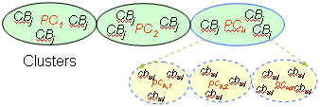
Query Image
Extract Features
(Primitives)
Image Database
Features Database
Similarity
Measure
Matched
Results
Figure 3.1 Flow of work
3.3 Detailed System Design
Detail design specifies who uses the Content Based Image Retrieval system outside the system i.e. within the environment, how the process within the system communicates along with how the objects with in the process collaborate using both static as well as dynamic UML diagrams in this ever-changing world of Object Oriented application development, it has been getting harder and harder to develop and manage high quality applications in reasonable amount of time.
As a result of this challenge and the need for a universal object modeling language every one could use, the Unified Modeling Language (UML) is the Information industries version of blue print. It is a method for describing the systems architecture in detail. Using this blue print, it becomes much easier to build or maintains system, and to ensure that the system will hold up to the requirement changes. This part also specifies the other levels of data flow diagram.

3.3.1 Use Case View
A use case diagram presents a collection of use cases and actors and is typically used to specify or characterize the functionality and behavior of a whole application system interacting with one or more external actors. The users and any system that may interact with the system are the actors. Since actors represent system users, they help delimit the system and give a clearer picture of what it is supposed to do. Use cases are developed on the basis of the actors needs. This insures that the system will turn out to be what the user expected.
Use case diagrams contain icons representing actors, association relationships, generalize relationships, packages, and use cases. A use case diagram shows the set of external actors and the system use cases that the actors participate in. A use case specification enables to display and modify the properties and relationships of a use case. The information in the specification is presented textually; some of this information can also be displayed inside the icon representing a use case. Use-case diagram is used to depict the requirements and the users of the CBIR.
The Use-case diagram as shown in below Figure 3.4 identifies the use cases and actors in CBIR. The use cases are
- Query by Image: Here the user gives the query image of JPEG format instead of query by text etc.
- Database Images: This use case contain a large list of images with which the query image is compared to extract related images..
- Feature Extraction of query image: Here the features of the query image are extracted and stored in the temporal storage.
- Feature Extraction of database images: Here the features of the database images are extracted and stored in the temporal storage
- Similarity Measurements: This use case carries the task of comparing the query image features with the database images individually and the matched result is obtained.
- Output Images: Here we display the images related to query image in serial form.

Content Based Image Retrieval
Database
Images
Feature
Extraction

Similarity
Measurements
Output
Images

Feature extraction

Query By Image
« include»

User
Web Designers
Military

Figure 3.2 Use Case Diagram of CBIR
The actors are
- User: user is the one present in the environment and uses the process involved in the system.
- Military: These are a type of users who can use the system to detect intruders and any attacks.
- Web Designers: these are another type of users who can use the system for web designing purpose.
- Query by Image: It is the image selected by the user to make a search.
- Feature extraction: It extracts the features of both query and database images.
- Database Image: These are images stored in the database by the user.
- Similarity Measurements: It compares the features of both query and database images.
- Output Images: The images which are similar to the query image are displayed to the user.
3.3.2 Level 1 DFD
In this diagram we will have the detail explanation of the context diagram of the system explained in preliminary design at the start of this chapter.
Level 1 DFD:
Query Image
It is a process and are the user provided images. The images should be of the format JPEG. CBIR uses the RGB color space to store information.
Feature Extraction
It is an external entity which helps to store the features of both query and database images.
Query Image Features
It is a process which extracts the features of the query images based on the method selected.
Image Collection: It is a process which adds the images in bulk to the database.
Feature Database: It uses Mysql for database storing.
Similarity Matching: It is an entity which compares the features of the query image and database images.
Retrieved Images: It is a process which displays the related images according to the query image to the user.

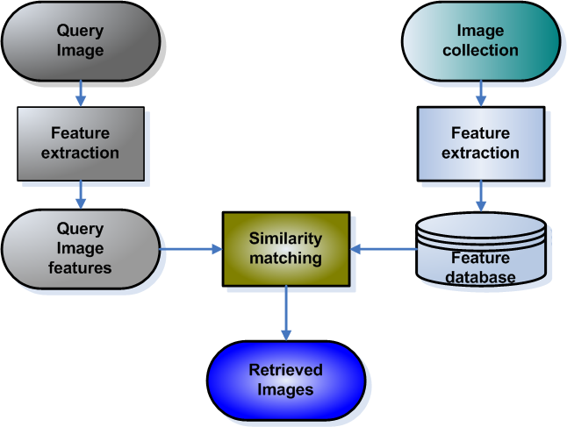

Figure 3.3 Data Flow Model of CBIR

    - Class diagram
Class diagrams are the backbone of almost every object-oriented method including UML. They describe the static structure of a system. Classes represent an abstraction of entities with common characteristics. Associations represent the relationships between classes.
Figure 3.5 is the class diagram of CBIR. The basic structure of the class diagram arises from the classes and relationship of the system is discovered at various points in the design process. The classes that are identified in this phase are
1.Addnew: The images to database are added individually or the folder of images can be added simultaneously. The dialog box of image insertion successful will to be displayed. Later the user can select the query image from any of the folder which is a real world entity.
Add New

AddNew( )
Filter

Filter( )

Discover Image

DiscoverImage( )
Feature Extraction

FeatureExtraction( )
Feature Tester

FeatureTester( )

CBIR
CBIR( )
GlobalColorHistogram

GlobalColorHistogram()
Average RGB

AvgRGB()
Color Conversion

ColorConversion( ) onversConversion()
image
image
image
1
*

*
*
*
1
1
1
Loacl Color Histogram

LocalColorHistogram( )
BMP Loader

BMPLoader( )
Color Moment

ColorMoment( )

Figure 3.4 Class diagram for CBIR
- BMP loader: The image will be divided into pixels and distributed according RGB.
- Filter: It checks the extension of the selected query image and the images added into the database.
4. Discover image: Checks whether the given image is in image format or text format.
5. Feature extraction: Extracts features of given query image and images in the database.
6. Feature Tester: Tests the features of the extracted from the images.
7. AVG RGB: Calculates the Avg RGB values of the query image as well as the images in the database.
8. Local/Global Color Histogram: The image will be divided into segments and histogram is compared with database images.

3.3.4 Sequence Diagram
Class and object diagrams are static model views. Interaction diagrams are dynamic. They describe how objects collaborate. A sequence diagram is an interaction diagram that details how operations are carried out what messages are sent and when. Sequence diagrams are organized according to time. The time progresses as you go down the page. The objects involved in the operation are listed from left to right according to when they take part in the message sequence.
The sequence diagram of Content Based Image Retrieval as shown below in Figure 3.6. The sequence of steps in the figure is as follows:
- Initially the user adds the images to the database and the even the query image is given by the user. The query image should be a real world entity and is of JPEG format.
- The search for the related images of the query image in the database is done using methods like AVG RGB, LOCAL and GLOBAL COLOR HISTOGRAM.
- The user selects anyone of the above methods to obtain related images from the database.
- Later the features of the query image is obtained based on the method selected by the user and stored temporarily. In the same way the features of the database images are extracted and stored.
The comparison between the features of the query image and the database images is carried out.
Use
Administrator
Image Folder
Group images of
database
Adds image to database
Inserting images to db
Images are inserted successfully
Figure 3.5 Sequence diagram of ADD NEW Module.
User
Image
Folder
Array
Buffer
Group images
From db
Similarity
Checking
start
Query image
Query features extracted

Comparing features of
Query and db images
Avg RGB,LCH
GCH,Texture
Output
(Related images and total time taken)
Group images
featuresextracted

Figure 3.6 Sequence Diagram of Color Histogram

3.4 Summary
In this chapter we came to know briefly about the preliminary design, layout of CBIR, technology used, design considerations, architectural strategies, modules of CBIR, interfaces, data flow diagram, detailed system design, use case view, level 1 DFD, class diagram, sequence diagram.

CHAPTER 4
IMPLEMENTATION
Implementation is the process of converting a new system design into an operational one. It is the key stage in achieving a successful new system. It must therefore be carefully planned and controlled. The implementation of a system is done after the development effort is completed. The system is fully implemented in java, and querying an image is implemented in Java and front page is built in java.
Steps for implementation:
- Installation of hardware and software utilities.
- Testing the developed system with sampled data.
- Detection and correction of errors.
- Data updating.
This chapter presents the implementation details for all modules that are:
Module 1: Add new module
Module 2: Color Histogram module
  - Add New Module
In this module administrator add the images to the database. The images to database are added individually or the folder of images can be added simultaneously. The dialog box of image insertion successful will be displayed. Later the user can select the query image from any of the folder which is a real world entity. If user go ahead with future process before adding the query image a dialog box indicating that query image is to be inserted.
The classes that are used to implement this module i.e. ADD NEW and OPEN images from those classes specified in the design phase is as follows:

Add New

class AddNew
{
AddNew(JFrame frame, JLabel label);

Void actionPerformed(ActionEvent ae);

Image getImage(String path);

Void cons(GridBagConstraints gbc, int gx, int gy, int gw, int gh, int wx, int wy);

boolean isImage(String path);
}
Add new class prototype of module 1
The prototype of this class is specified in Add New the header file is as shown above.
AddNew(JFrame,JLabel)
Input: The frame and label of the front end screen.
Output: It creates the frame and adds the label to the created frame.
Description: This prototype creates the frame in which all the interactive process is carried out of the user and even the label is also created. The frame size can be mentioned by the user. It is an constructor which has the same name as the class.
void actionPerformed(ActionEvent ae)
Input: The action to be performed .
Output: The action specified by the function will be performed.
Description: The action to be performed my the buttons will be carried out by a click on the botton. It is an in built function.This is inherited by the AddNew class.

Image getImage(String path)

Input: The path of the image.

Output: The image is obtained from the particular path provided.

Description: The images required to be added to the database can be obtained.Even the query image is obtained and displayed on the front end screen. This is also a in built function.

void cons(GridBagConstraints gbc, int gx, int gy, int gw, int gh, int wx, int wy)

Input: The gridBagConstraint, x and y value, width and height, weight of x and y.

Output: It obtains the gridbag constraint.

Description: The grid bag layout is added. It returns nothing to the main function hence the return type is void. This is too a in built function in one of the java package.

boolean isImage(String path)

Input: The path of the image.

Output: True or false value.

Description: It checks whether the path mentioned to obtain the image is true or false. It has a Boolean type of return value i.e true or false.
Class filter
Class filter
{
Filter(String[] ext)

public boolean accept(File name)

public String getDescription();

}

Class fliterclass prototype of module 1
Filter (String[] ext)
This function is used check for the image file which has .ext extension.

boolean accept(File name)
Input : The filename of the file to be loaded is specified.
Output: File is loaded with read features.
Description: this function is used to accept the file name which ends with .ext extension. It has a Boolean type of return value i.e. true or false.
String getDescription();

This function upon true value returns a image file.
Class BMP loader

public class BMPLoader

{

public static int constructInt(byte[] in, int offset)

public static int constructInt3(byte[] in, int offset)

public static double constructDouble(byte[] in, int offset)

public static Image read(FileInputStream fs)

protected static Image readMap32(FileInputStream fs, BitmapHeader bh)

public static Image load(String sdir, String sfile)

public static Image load(String sdir)

BMPLoader(String a)

BMPLoader()

}

BMP Loader prototype module 1
static int constructInt(byte[] in, int offset)

Input:It takes an array of byte and an offset value.

Output:It returns the value of ret to the constructor.

Description: Constructs objects from the database query process. Returns the number of database records read. Build an int from a byte array - convert little to big endian.
static int constructInt3(byte[] in, int offset)
Input: It takes an array an of byte and an offset value.

Output: It returns the value of ret to the constructor.

Description: Constructs objects from the database query process.Build an int from a byte array - convert little to big endian and set high order bytes to 0xfff.
static double constructDouble(byte[] in, int offset)

Input:It takes an array an of byte and an offset value.

Output:It returns the value of ret to the constructor.

Description: It constructs an objects for the database query process.Build an double from a byte array - convert little to big endian.
static Image read(FileInputStream fs)
Input:It reads an input stream file fs.
Output:It catchs an IOexception if image check is null.
Description:It reads Map24 internal routine to read the bytes in a 24 bit bitmap and returns an image object, and it will be sure to check for (Image)null.
static Image readMap32(FileInputStream fs,BitmapHeader bh)
Input:It reads an input stream file fs and byte data that contains the file information.

Output:The Image that contains the bitmap.

Description:It readMap32 reads a 32 bit bitmap file.

static Image load(String sdir, String sfile)

Input:It takes an string directory value sdir and a string file value as sfile.

Output:Its returns the values of both sdir and sfile.

Description: The image load makes it easy to load images in either of two formats: GIF and JPEG.
static Image load(String sdir)
Input:It takes an string directory value sdir.

Output:It returns an null if image loading catchs an IOException.

Description: If the load images is neither of two formats: GIF and JPEG than it throws an IOException.
Class Viewer2
Class Viewer2
{
void paint(Graphics g)

Image getImage(String path)

}

Class Viewer prototype of Module 1
void paint(Graphics g)

This function is used to draw image size in the frame.

Image getImage(String path)
Input : The function takes path as a string.
Output: The Path of the image will be obtained.
Description: This function is used get path of the image with the extension .jpg or.fig

Class UserDAO
Connection getConnection()
This function gets connection with the local host.
void closeConnection()
This function closes the connection connected to the local host.

boolean insert(String name, String description, String path)
The function takes name, description and the path of the image and stores into the data base

public class UserDAO

{
Connection getConnection()
void closeConnection()
boolean insert(String name, String description, String path)
boolean preInsert(String path)
int retrive()
}

UserDAO prototype of Module 1
boolean preInsert(String path)
This function is used to insert the image as query image as specified in the path.
int retrive()
This function is used to retrieve a set of images from the databases which is similar to the query image.
Exceptions in Java
- Throw able Class
The Throw able class provides a String variable that can be set by the subclasses to provide a detail message that provides more information of the exception occurred. All classes of throwables define a one-parameter constructor that takes a string as the detail message.
The class Throw able provides get Message () function to retrieve an exception. It has a printStackTrace () method to print the stack trace to the standard error stream. Lastly It also has a toString () method to print a short description of the exception. For more information on what is printed when the following messages are invoked, please refer the java docs.
Syntax
String getMessage()
void printStackTrace()
String toString()
- Class Exception
The class Exception represents exceptions that a program faces due to abnormal or special conditions during execution. Exceptions can be of 2 types: Checked (Compile time Exceptions)/ Unchecked (Run time Exceptions).
- Class RuntimeException
Runtime exceptions represent programming errors that manifest at runtime. For example ArrayIndexOutOfBounds, NullPointerException and so on are all subclasses of the java.lang.RuntimeException class, which is a subclass of the Exception class. These are basically business logic programming errors.
- Class Error
Errors are irrecoverable condtions that can never be caught. Example: Memory leak, LinkageError etc. Errors are direct subclass of Throwable class.
4.2 Average RGB
The red, green and blue color intensity of query image is calculated and compared with the RGB values of database images and related images are displayed as output.
AverageRGB
public class AverageRGB extends FeatureExtractionModule
{

public AverageRGB();

public Vector getFeatureVector(DiscovirImage discovirimage);

public double compareFeatureVector(Vector vector, Vector vector1);

}
AverageRGB prototype of Module 2
AverageRGB()
Input:No input is given.
Output:Adds the description of the image features.
Description: The name, length, category version and the description of the feature of the image will be added.
Vector getFeatureVector(DiscovirImage discovirimage)

Input:The discovered image i.e the image of the JPEG format.

Output:The vector of the features extracted from the image.

Description: The RGB pixels of the image are considered and the total value of the red, blue and green is extracted. These obtained values are returned as the vector to the calling function.
double compareFeatureVector(Vector vector,Vector vector1)

Input: The vector value features of the query image and the vector of the database images.
Output: The value obtained after the calculation.
Description: The vectors of the query image and the each and every image of the database image are compared. If the relevant value is obtained then the database images is added to be output list of images.
4.3 Local Color Histogram
The image will segmented into and color histogram of each block will be obtained. We calculate the distance, using their histograms, between a region in one image and a region at same location in the other image in database.
LOCAL COLOR HISTOGRAM

public class LocalColorHistogram

{

public LocalColorHistogram()

public Vector getFeatureVector(DiscovirImage image)

public Vector getFeatureVector(DiscovirImage image, int d)

private int decideLocal(double j, double w, double h, int d)

public double getThreshold()

}

Local Color Histogram prototype of Module 2
Local ColorHistogram()
Input:No input is given.
Output:Adds the description of the image features.
Description: The name, length, category , version and the description of the feature of the image will be added.
Vector getFeatureVector(DiscovirImage image)
Input:The discovered image i.e the image of the JPEG format.

Output:The vector of the features extracted from the image.
Description: The image is segment into blocks and then obtains a color histogram for each block. When comparing two images, we calculate the distance. The distance between the two images will be determined by the sum of all these distances. These obtained values are returned as the vector to the calling function.
Vector getFeatureVector(DiscovirImage image, int d)

Input: The discovered image i.e. the image of the JPEG format and distance is taken.
Output: The vector of the features extracted from the image.
Description: The image is segment into blocks and then obtains a color histogram for each block. When comparing two images, we calculate the distance. The distance between the two images will be determined by the sum of all these distances. These obtained values are returned as the vector to the calling function.
int decideLocal(double j, double w, double h, int d)

Input: It takes width, height and distance of a given image and double variable.

Output: It returns the area of the image.

Description: using width, height and distance it calculates the distance between the query image and the database images and displays the best matched images as output.
4.4 Global Color Histogram:
Same as the local color histogram but considers all the regions of the image.The classes that are used to implement this module i.e. Color Histogram from those classes specified in the design phase is as follows:
GLOBALCOLORHISTOGRAM:
GlobalColorHistogram()
Input: No input is given.
Output: Adds the description of the image features.
Description: The name, length, category, version and the description of the feature of
the image will be added.
Vector getFeatureVector(DiscovirImage image)
Input: The discovered image i.e. the image of the JPEG format.

Output: The vector of the features extracted from the image.

Description: The color histogram depicts color distribution using a set of bins. Using
the GCH, an image will be encoded with its color histogram, and the distanc between two images will be determined by the distance between their color histograms.This obtained values are returned as the vector to the calling function.
public class GlobalColorHistogram extends FeatureExtractionModule

{

public GlobalColorHistogram()

public Vector getFeatureVector(DiscovirImage image)

}
Global Color Histogram prototype of Module 2

FEATURE TESTER
public class FeatureTester

{

static void processFile1(File fileHandle)

void processFile(File fileHandle)

void compute()

}

Feature Tester prototype of Module 2
Static void processFile1 (File fileHandle)
This function process for an image file using a DiscovirImage() function to check whether the file is a image or a text file.
Void processFile(File fileHandle)
This function process for the images in the database as per the features of the query image and will display the total time consumed to read the images from the data base.
Void compute()
This function is used to compute feature vectors of the query image and the database images.
FEATURE EXTRACTION
public abstract class FeatureExtractionModule
{
public FeatureExtractionModule()
public double getThreshold()
public String getFeatureName()
public abstract Vector getFeatureVector(DiscovirImage discovirimage);
public Vector getFeatureVector(BufferedImage image)
public double compareFeatureVector(Vector a, Vector b)
public double compareFeatureString(String a, String b)

public String vector2String(Vector vec)
public Vector string2Vector(String str)
}
Feature Extraction prototype of Module 2

String getFeatureName()

It gives the name of the feature extraction method used for that particular
search.

abstract Vector getFeatureVector(DiscovirImage discovirimage)

Input: The discovered image i.e. the image of the JPEG format.

Output: The vector of the features extracted from the image.
Description: The feature extraction is done using methods as avg rgb,local and global color histogram etc and distance values are calculated. This obtained values are returned as the vector to the calling function.
double compareFeatureVector(Vector a, Vector b)
Input: The vector value features of the query image and the vector of the database images.
Output: The dimensions of the both images are given.
Description: The vectors of the query image and the each and every image of the database image are compared. If the relevant value is obtained then the database images is added to be output list of images.
double compareFeatureString(String a, String b)
Input: The string value features of the query image and the string value of the database images.
Output: The value obtained after the calculation.
Description: The string value of the query image and the each and every image of the database image are compared. If the relevant value is obtained then the database images is added to be output list of images.
String vector2String(Vector vec)

Input: The vector value of the vectors.

Output: The converted string value is obtained.

Description: All the values that are stored in vector are converted into a string value.

Vector string2Vector(String str)

Input: It takes the string value.

Output: The converted vector value is obtained.

Description: After the process got over all the string values are converted back into vector values.

Creation of User profiles and access rights

There are two types of users in Robust Content Based Image Retrieval.

1. Admin Login
2. User Login
Admin User
Admin is the super user and he has all the rights over the database.
Admin has the rights to create new user or members to access the RCBIR system.
Admin can create and change the user profiles.
Admin can add new images or change the details of the images in the database.
Admin has the full rights to update/modify the details in the database.
User profile

User can access the images in the database by passing an input image as parameter.
User can have a look at the images in the database but doesnot have any rights to modify or create new image in the database.
4.5 Summary
In this chapter we came to know briefly about the implementation of Add New Module, Average RGB, Local Color Histogram, Global Color Histogram.

Chapter 5
TESTING
This chapter gives the outline of all the testing methods that are carried out a get a bug free system. Quality can be achieved by testing the product using different techniques at different phases of the project development.

5.1 Testing process
Testing is an integral part of software development. Testing process, in a way certifies, whether the product, that is developed, compiles with the standards, that it was designed to. Testing process involves building of test cases, against which, the product has to be tested. In some cases, test cases are done based on the system requirements specified for the product/software, which is to be developed.

5.2 Testing objectives
The main objectives of testing process are as follows:
- Testing is a process of executing a program with the intent of finding an error.
- A good test case is one that has high probability of finding an as yet undiscovered error.
- A successful test is one that uncovers an as yet undiscovered error.

5.3 Levels of testing
Different levels of testing are used in the testing process; each level of testing aims to test different aspects of the system. The basic levels are unit testing, integration testing, system testing and acceptance testing

5.3.1 Unit Testing
Unit testing focuses verification effort on the smallest unit of software design the module. The software built, is a collection of individual modules. Each module performs a unique function. In this kind of testing, exact flow of control for each module was verified. With detailed design Considerations used as a guide, important control paths are tested to uncover errors within the boundary of the module.
The Unit Test can be conducted in parallel for multiple modules. Table 5.1 shows the test conducted on the basic module of the system ie insertion of the new image. Table 5.2 shows the test conducted on the color histogram and texture modules.
- Module to open and insert images:

Table 5.1 Test Cases for FILE opening and ADD NEW Module
Steps | Action | Expected Results
Step 1 | Execution of CBIR.java as show in snapshot1 of Appendix A. | The project is opened in java swing as shown in Snapshot 2 in Appendix A.
Step 2 | Click on Enter button in snapshot2 of Appendix A. | The Snapshot3 of Appendix A should be displayed.
Step 3 | Click on NEW menu shown in Snapshot4 of Appendix A. | Choose an Image or a Folder to add images to the database (MySQL yog). If the images are successfully inserted DialogBox1 of Appendix A will be displayed.
Step 4  Step 5 | Click on FILE menu of Snapshot5 of Appendix A.  Click on the folder containing images to select query image from the system | The snapshot6 of Appendix  A should be displayed.  The Snapshot7 of Appendix A should be displayed.

Modules processing Color Histogram:

Table 5.2 Test Cases for modules color histogram.
Test Case Description | Check the properties of all objects in running module 2 and 3.

Steps | Action | Expected Results
Step 1 | Click on Color Histogram menu shown in Snapshot3 of Appendix A. | Snapshot8 of Appendix A is displayed.
Step 2 | Click on any one of the options of Color Histogram menu i.e. AverageRGB, Local and Gobal Histogram which are shown in Snapshot8 of Appendix A. | The Snapshot9 of Appendix A should be displayed. Here the resultant images are displayed as per options selected.

5.3.2 Integration testing
The second level of testing is called integration testing. In this, many class-tested modules are combined into subsystems, which are then tested. The goal here is to see if all the modules can be integrated properly. We have integrated all the classes and have checked for compatibility. Errors obtained are identified and debugged.
5.3.3 System Testing
Here the entire software system is tested. The reference document for this process is the requirements document, and the goal is to see if the software meets its requirements.
Debugging is not always easy. Some bugs can take a long time to and. Debugging concurrent code can be particularly difficult and time consuming. It helps to understand the language and its libraries. A common source of errors in Java is to use libraries without properly understanding what methods do and how they work. For example, one might forget to call a method to initialize an object.
It is a good idea to add toString methods to your own classes. Then when debugging you can simply print out an object of that class and see some of its data. You will see this in the example below. It is also a good idea to add a main method to your class, which does some testing of that class. Then the class can be executed directly and you can test your classes separately.
Each module and component was thoroughly tested to remove bugs through a System testing strategy. Test cases were generated for all possible input sequences and the output was verified for its correctness. Test cases for system testing are mentioned below.
Table 5.3 Test Cases for Content Based Image Retrieval System
Test Case Description | Check the properties of all objects in running system.

Steps | Action | Expected Results
Step 1 | Click on Color Histogram menu of Snapshot8 of Appendix A. | The retrieved images are displayed as shown in Snapshot9.
Step 2 | Click on Texture menu of Snapshot10 of Appendix A. | The Snapshot11 of Appendix A is displayed where retrieved images are displayed.

Validation Checks
- Login Page:
Validation is done when
    - Username is empty.
    - Password is empty.
    - Authentication of username and password.
- Admin Login:
Validation is done when creating new user.
- UserID is empty.
- Password is empty.
Validation is done when admin uploads new image to the database.
- Name of the image to be uploaded is empty.
- Description of image to be uploaded is empty
Validation is done when admin uploads new image folder to the database.
- Name of the image to be uploaded is empty.
- Description of image to be uploaded is empty
- User Login:
Validation is done when user opens a files from the local drive as an input image.
- Name of the image to be uploaded is empty.
- Description of image to be uploaded is empty

5.4 Summary
In this chapter we came to know briefly about the testing process, testing objectives, levels of testing which includes unit testing, integration testing and system testing.

CHAPTER 6
CONCLUSION AND FUTURE ENHANCEMENT
6.1 Conclusion
The need for Content- Based image retrieval is to retrieve images that are more appropriate, along with multiple features for better retrieval accuracy.“Content-based” means that the search makes use of the contents of image themselves, rather than relying on human-inputted metadata such as captions or keywords. The similarity measurements and the representation of the visual features are two important tasks in Content-Based Image Retrieval (CBIR).Given a query image, with single object present in it; mission of this work is to retrieve similar kind of images from the database based on the features extracted from the query image. We use content- based search, for high accuracy multiple features like color, texture and shape is incorporated. In this project, we implemented a CBIR system based on multiple features representations which include: Color Feature through GCH & LCH. Color feature extraction is done through “Global Color Histogram (GCH)” and “Local Color Histogram”.
6.2 Future Enhancement
The further enhancements of the project are as follows:
- To reach 100% of accuracy
- We are currently extending the system to deal with range of aspects such as the display of name and description of query and resultant images on the output screen.

References
[1] John Eakins and Margaret Graham, “Content-based Image Retrieval”, JISC
Technology ApplicationsProgramme. University of Northumbria at Newcastle.
January 1999
[2] Rui Y. & Huang T. S., Chang S. F. “Image retrieval: current techniques,
directions, and open issues”. Joumal of Visual Communication and Image
Representation, 10,39-62,.
[3] Karin Kailing, Hans-Peter Kriegel and i Stefan Schonauer, “ Content-Based
Image Retrieval Using Multiple Representations”. Proc. 8th Int. Con€. On
Knowledge-Based Intelligent Information and Engineering Systems
(KES’2004), Wellington,New Zealand, 2004, pp. 982-988. I
[5] Ahmed M.Ghanem, Emad M. Rasmy, and Yasser M, Kadah, “Content-Based
Image Retrieval Strategies for Medical Image Libraries,” Proc. SPIE Med.
Imag., San Diego, Feb.2001
[6] Henning Muller, Wolfgang Muller, David McG. Squire and Thierry Pun,
Performance Evaluation in Content-Based Image Retrieval: Overview and
Proposals. Computing Science Center, University of Geneva, Switzerland, 2000.
[7] http://www.unn.ac.uWiidr/report.htrnl.
[8] http://wang.ist.psu/~jwang/test.html.
[9] Shengjiu Wang, “A Robust CBIR Approach Using Local Color Histograms,”
Department of Computer Science, University of Alberta, Edmonton, Alberta,
Canada, Tech. Rep. TR 01-13, October 2001, Found at:
[10] Raghu Krishnapuram, Swarup Medasani, Sung-Hwan Jung, , Young-Sik Choi,
and Rajesh Balasubramaniam “Content-Based Image Retrieval Based on a
Fuzzy Approach” OCTOBER 2004.
[11] S. Kulkarni, B. Verma1, P. Sharma and H. Selvaraj “Content Based Image
Retrieval using a Neuro-Fuzzy Technique” 2005.
[12] Wang Xiaoling, Xie Kanglin, “Application of the Fuzzy Logic in Content-based
Image Retrieval1” April 2005.
[13] Rouhollah Rahmani, Sally A. Goldman, Hui Zhang, John Krettek, and Jason E.
Fritts “Localized Content Based Image Retrieval” MIR’05,
[14] Ying Liua, Dengsheng Zhanga, Guojun Lua,Wei-Ying Mab “A survey of
content-based image retrieval with high-level semantics” 2006
[15] Giorgio Giacinto “A Nearest-Neighbor Approach to Relevance Feedback in
Content Based Image Retrieval”

Appendix A
Snapshots

Figure A1 shows snapshot of the execution of the Java file specifying to open the project. Once the command prompt is displayed we execute using javac command, which will internally call the java complier to compile and execute the file BackgroundImagePanel.java file to open the first output page of the project.

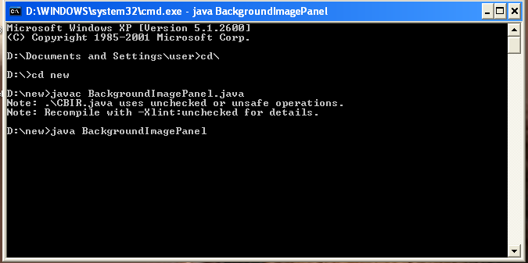

Figure A1 Execution of The Java File

Figure A2 shows snapshot of the front page of the system from where the application should run. Here display of front page along with Enter button is shown. On this page when Enter button is clicked it proceeds to the next output page of the project i.e Snapshot 3

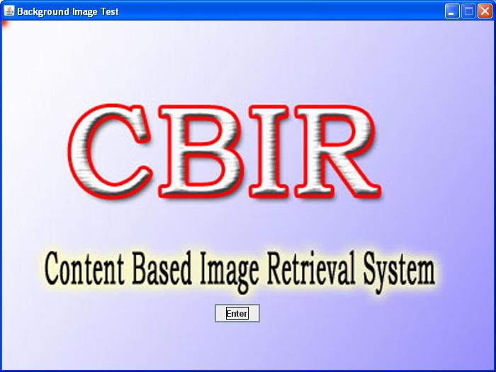

Figure A2 Front Page of The Application

Figure A3 shows snapshot of the login page of the system from where the application should run. Here display of login page along with user ID Textfield, user password Textfield and Login button is shown. On this page when authentic user ID and user password is given and then Login button is clicked it proceeds to the next output page of the project i.e Snapshot 4.

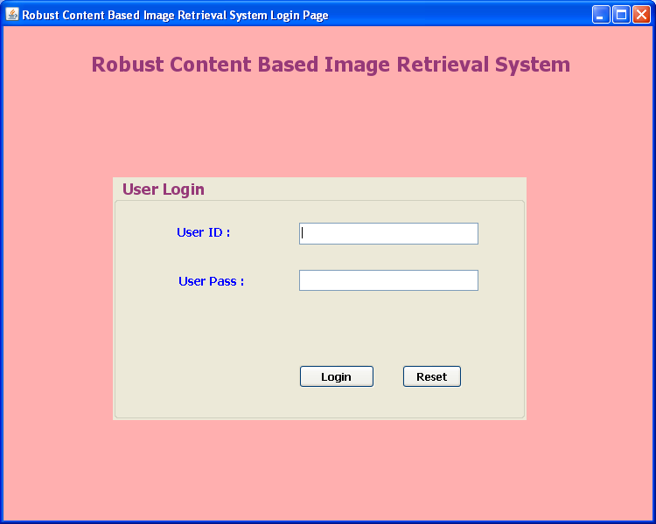
Figure A3 Login Page .

Figure A4 shows snapshot of Administrator main screen with menu options. The menu options such as User, File, Color Histogram and New can be selected to perform a particular function.
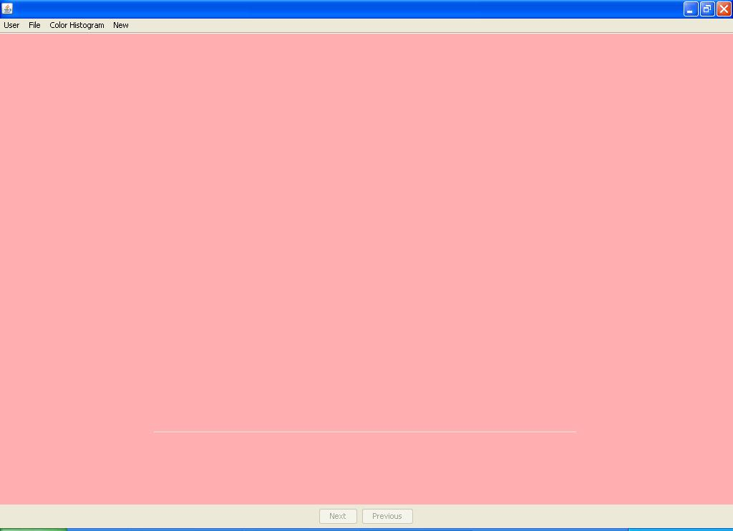
Figure A4 Administrator Main Screen With Menu Options

Figure A5 shows snapshot of module 1 of the system. The snapshot4 shows the User ID Textfield, User role Combobox, password Textfield, confirm password Textfield, submit and reset button. Here a User can be added to the Database using the Submit button which is shown in the snapshot below.

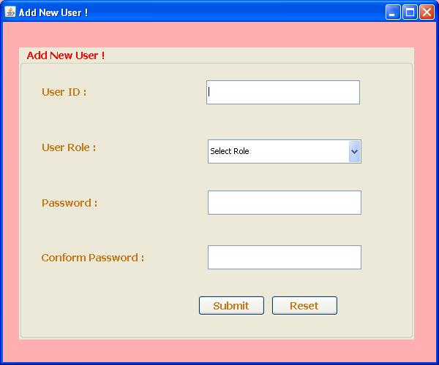

Figure A5 Administrator Adding New User

Figure A6 shows snapshot of deleting the User from the system. The snapshot4 shows the User ID Textfield, User role Combobox, delete and reset button. Here a User can be deleted by Administrator from the Database using the Delete button which is shown in the snapshot below.

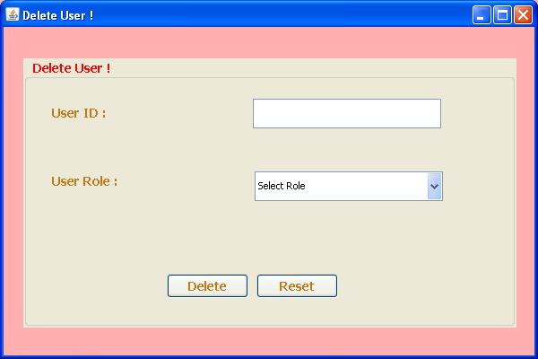

Figure A6 Administrator Deleting The User

Figure A7 shows snapshot of adding images to database. The snapshot 7 shows the New menu and the options available with it which are AddNewImage and AddNewFolder. Here a single image can be added to the Database using the AddNewImage option which is shown in the snapshot below. The entire folder of images can also be added to the Database using AddNewFolder option which is shown in the snapshot below.

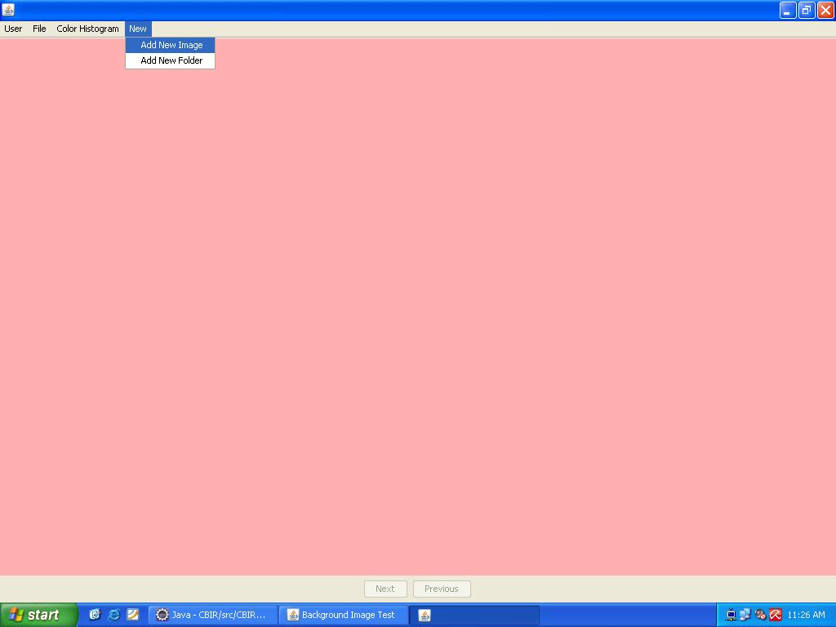

Figure A7 Main Screen To Add An Image Or A Folder Options

Figure A8 shows snapshot of module 1 of the system. The snapshot 8 shows the File menu along with the Open option with it where the query image is opened for the project.

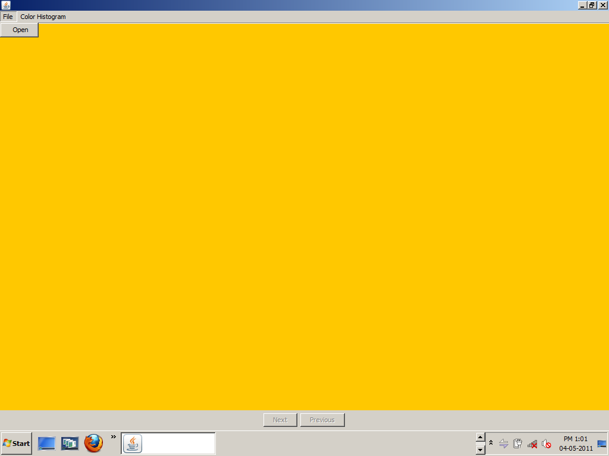

Figure A8 Main Screen To Open A Query Image

Figure A9 shows snapshot where the query image from the folder selected is displayed.
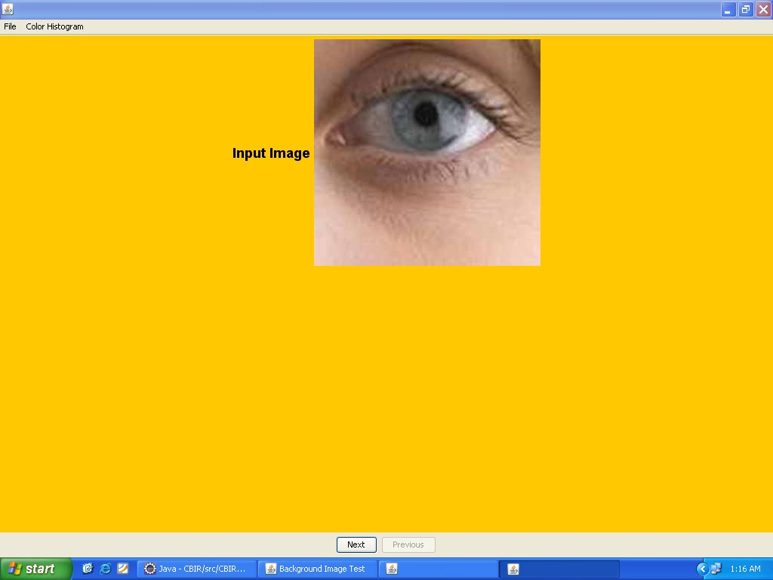

Figure A9 Displays The Query Image From The Folder

Figure A10 shows snapshot of module 2 of the system. The snapshot 10 shows the Color Histogram menu and the options available with it which are Average RGB, Local Color Histogram, Global Color Histogram.

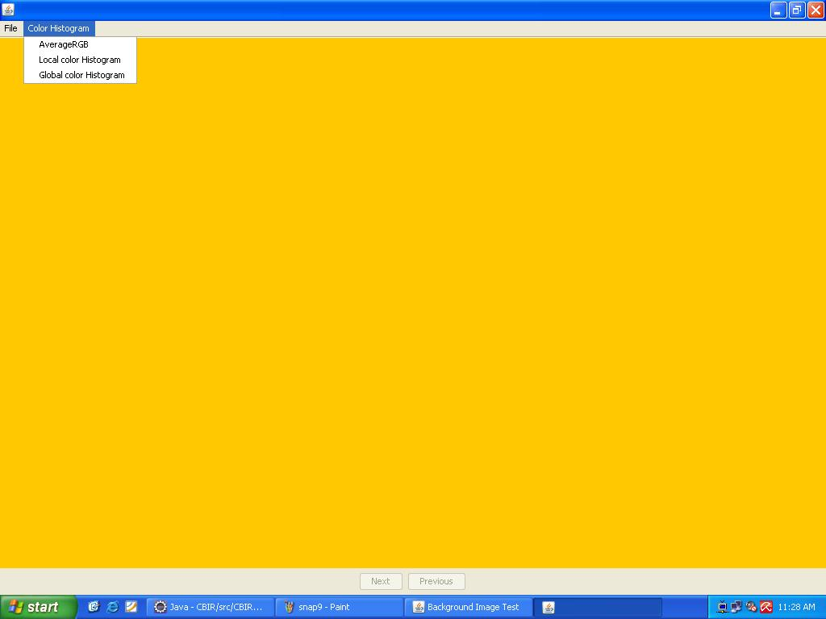
Figure A10 Menu Options For Color Histogram

Figure A11 shows snapshot of output of module 2 of the system. The snapshot 11 shows the output of Color Histogram menu and the options available with it which is Average RGB. The red, green and blue color intensity of query image is calculated and compared with the RGB values of database images and related images are displayed as output. It also displays the Total time used.

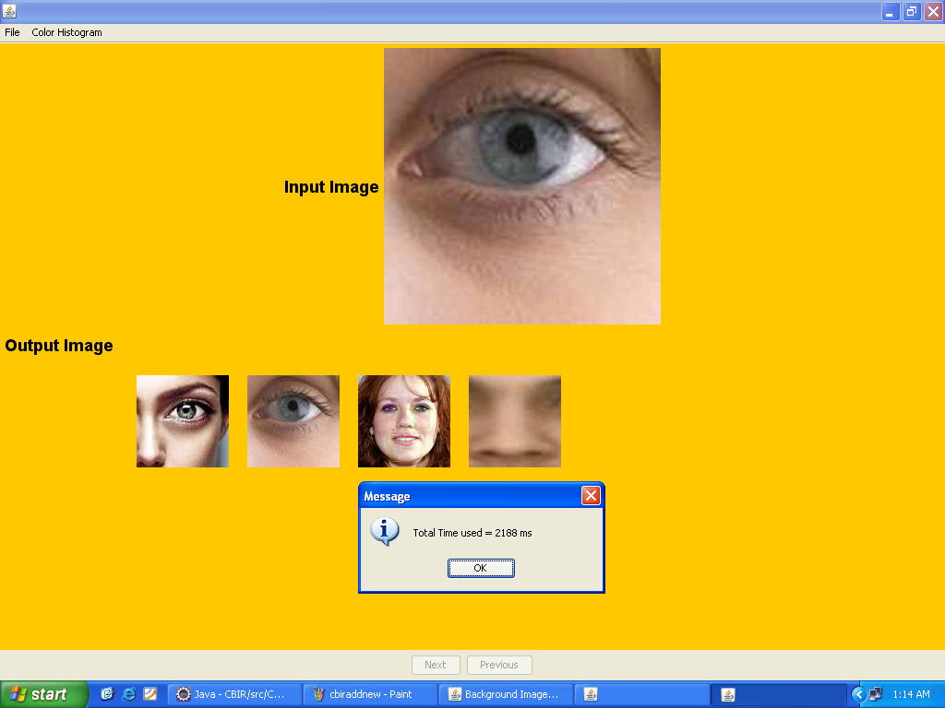
Figure A11 Average RGB

Figure A12 shows snapshot of output of module 3 of the system. The snapshot 12 shows the output of Color Histogram menu and the options available with it which is GlobalColorHistogram. The image will segmented into and color histogram of each block will be obtained. We calculate the distance, using their histograms, between a region in one image and a region at same location in the other image in database. It also displays the Total time used.

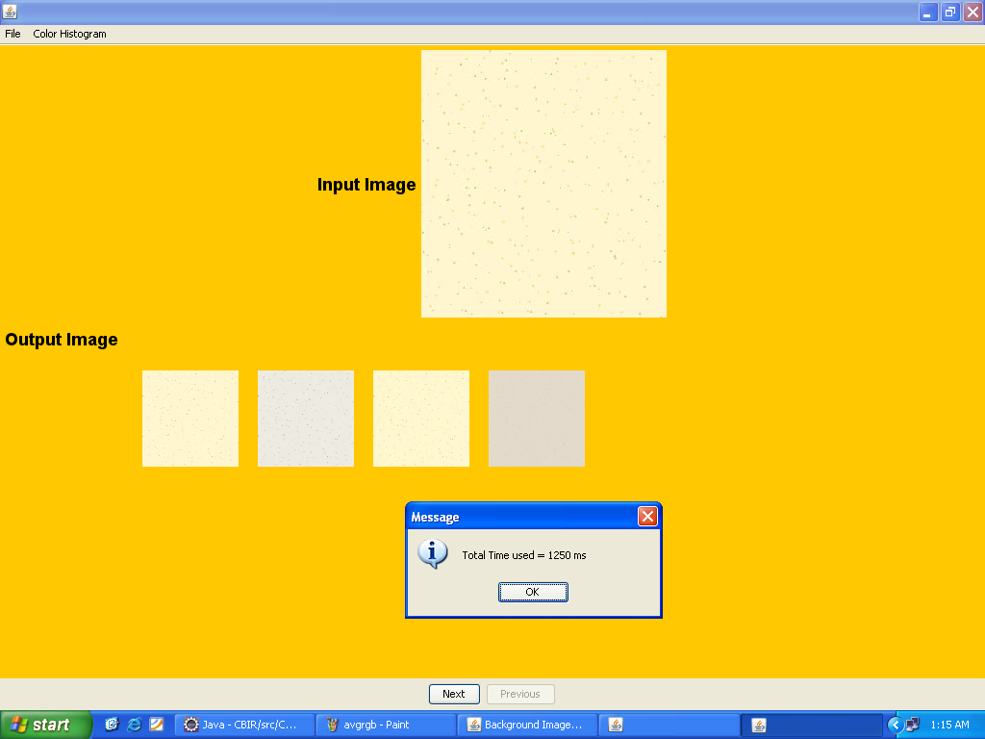

Figure A12 Global Color Histogram
Figure A13 shows snapshot of output of module 4 of the system. The snapshot13 shows the output of ColorHistogram menu and the options available with it which are LocalColorHistogram. Global color histogram of each block will be obtained. We calculate the distance, using their histograms, between a region in one image and a region at same location in the other image in database. Same as the local color histogram but considers all the regions of the image. It also displays the Total time used.

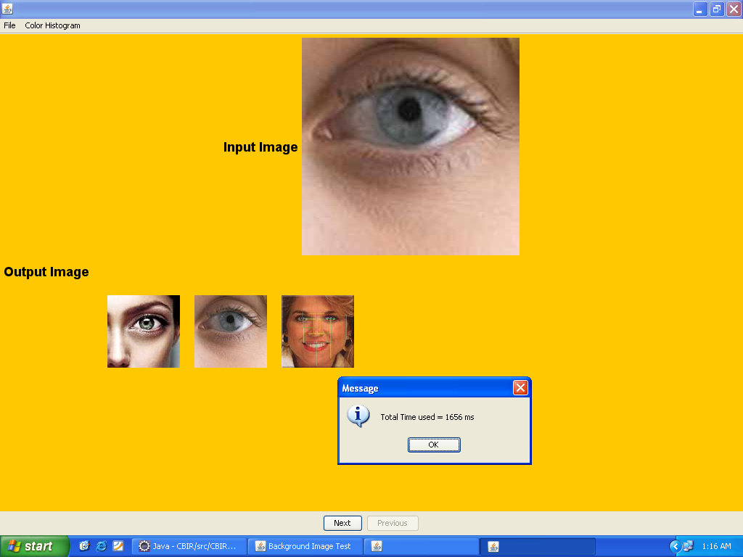
Figure A13 Local Color Histogram

